
Reinforcement (2016-17) Name: ________________________
Subject: Hindi Class: 1 Division: _________
Date: Roll No: _______________________

Instructions:
- All questions are compulsory.
- Read the questions carefully before attempting.

Q1. Fill in the blanks
- Collection of information is called ____________.
- Arranging data in an organised order is called____________.
- F_ _T Y.
- F_ F T Y.
- N_ _ E_ Y N_N_.
- N _ N _ T _ _ N.
- S E _ E_ _ EE N.
- T _ _ R _ _ N E.
- _ I G _ _ _ FOUR.
- _ W _ N T_.
- Sdasda
- asd
Q2. Write the number names for the following
43 _______________________
69_______________________
19 _______________________
36_______________________
99_______________________
96_______________________
23_______________________
90_______________________
78_______________________
66_______________________
31_______________________
14_______________________
100_______________________
11 _______________________
0 _______________________
12 _______________________

Q3. Write the numbers for the following
- Ninety-one
- Eighty-seven
- Thirty-six
- Ninety one
- Forty
- Thirty-two
- Fifty-nine
- Sixty one
Q4.
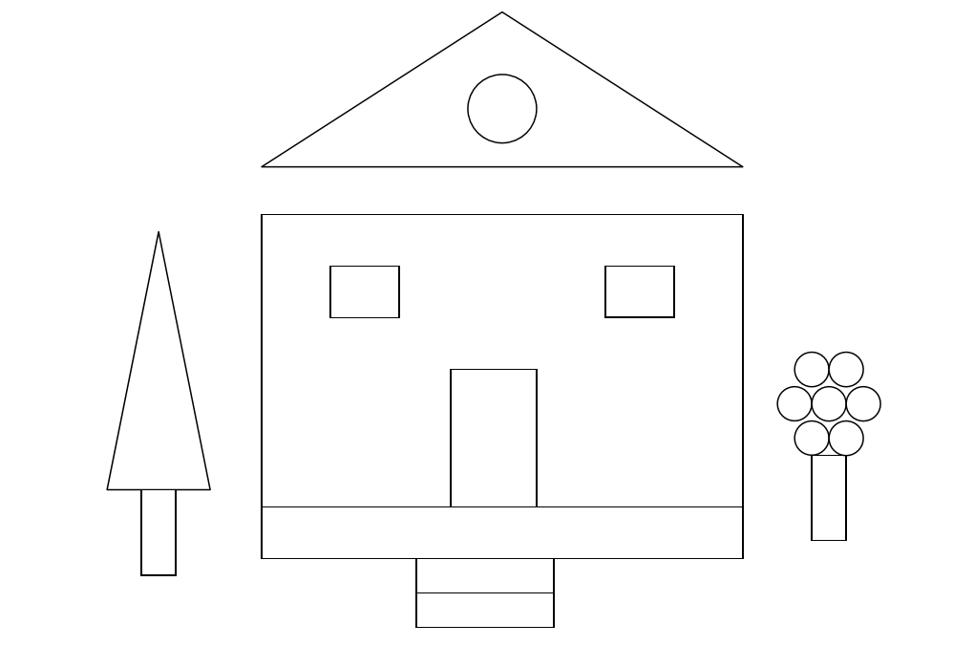
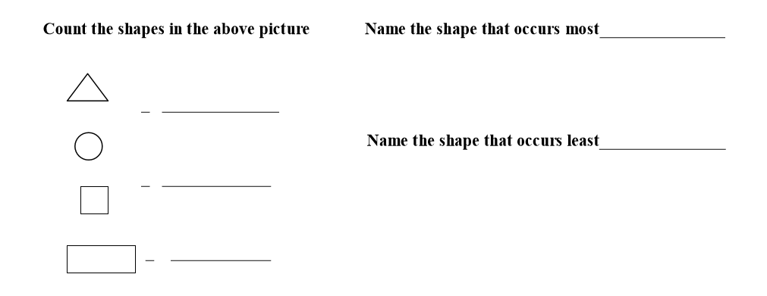
Which is more, circles or squares? _______________
Write the number of curved shapes in the picture________________

Q5. Match them
19
78
90
84
49
Forty nine
Eighty four
Nineteen
Seventy eight
Ninety

Q6. Fill in the blanks with number names
- 76,________________, 78
- 12,________________, 14
- 39,________________, 41
- 97, 98, 99, ______________.
- 54,_____________,56
- ___________________, 64.
- 19, ______________, 21
- 7,_____________, 9.
Q7. Count the fruit in each group. Then tick the correct number
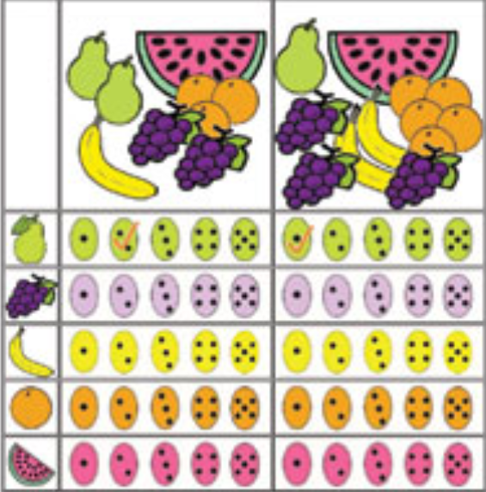

Q8.Studythe picture given below carefully and answer the questions

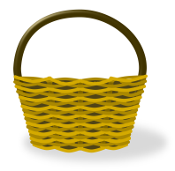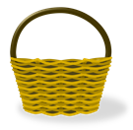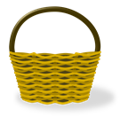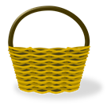

Number
Ball
Basket
Girl
Boy
Balloon

- How many children are there the picture? _______________
- There are _____ boys more than the girls.
- Which are more, balls or baskets? ___________
- There are 6 balls. What else is 6 in number? _________

Q 8 Riya did a survey, she asked them their favourite vegetable.

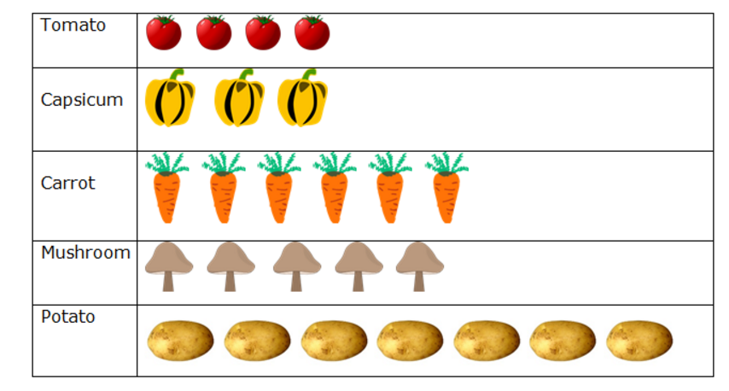

- How many children like tomato? _____________________
- Which vegetable do you think is most popular one? ____________________
- How many children choose capsicum as their favourite vegetable? ______________
- Which vegetable is the least popular choice? ______________
- Which is your favourite vegetable? __________________

Q9. Max has many toy cars
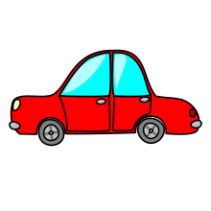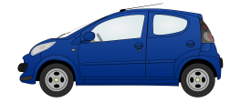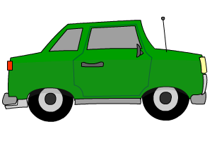

Colour | Number

- How many blue cars are there with Max? _____________________
- Which colour car does Max has the most?____________________
- Max painted his pink cars blue. Now how many blue cars Max has______________
- Max broke one of his yellow cars. Now the number of yellow car is equal to ______ colour cars.

